Ian Kilgore

1/12/2018

Fossil Occurrence and the Age of Rocks

Problem:

How can the occurrence of fossils and their known age ranges be used to date rocks?

Materials:

* Geologic time scale
* Graph paper
* Pencil

Procedures:

1. Using the diagram on page 272, record the number of times earth’s magnetic field has reversed polarity in the last 4 million years
2. Using the diagrams on page 273, observe that the patterns of polarity in the rock match on either side of the ridge in all ocean basins.
3. Using the diagrams on page 273, identify and mark the periods of normal polarity, with the letters a-f. Begin at the rift valley and label along both sides of the ridge.
4. Using the South Atlantic diagram, label the beginning of the normal polarity period C, “2 million years ago” on the left sides of the Pacific North Atlantic diagrams.
5. Using the distance scale shown on page 273, determine which ocean basin has spread the greatest distance during the last two million years.
6. Note that the left side of the south atlantic basin has spread approximately 39 kilometers from the center of the rift valley in two million years.

Diagrams:

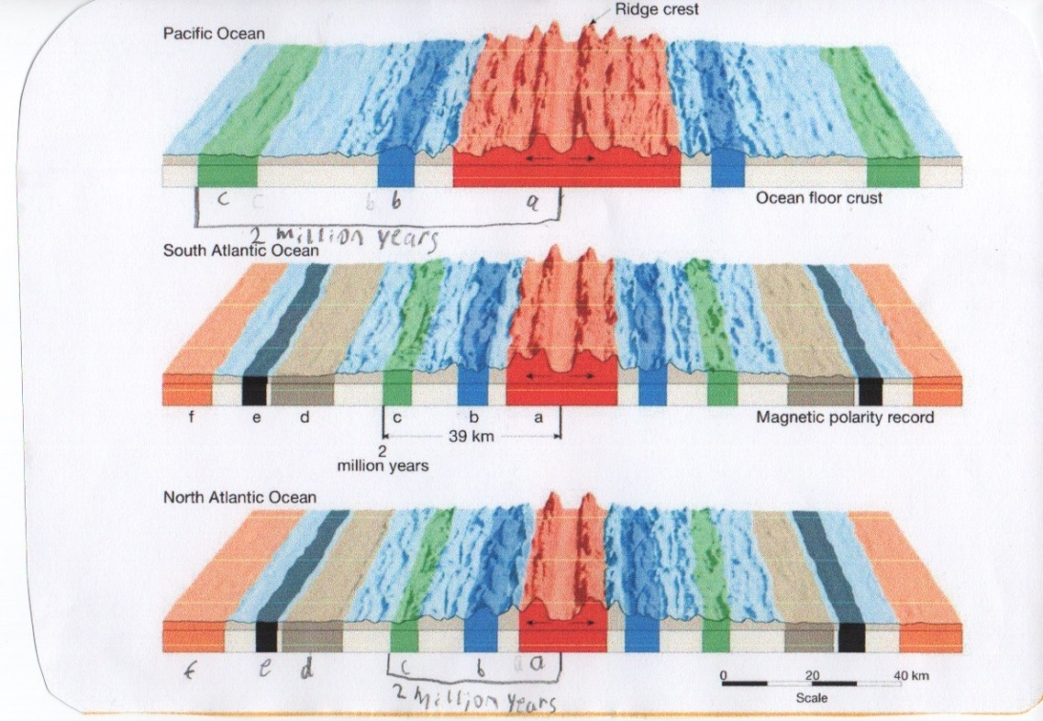

Analyze and Conclude:

1. Pacific basin spread in last two million years = 40km \* 2 = 80km
2. North atlantic basin spread in last two million years = 39km \* 0.95 = 37.11km
3. Pacific basin = 80km \* 2 = 160 km. North Atlantic basin = 37.11km \* 2 = 74.22km. South Atlantic basin = 39km \* 2 = 78km.
4. South atlantic rate of sea floor spreading 39km = 39,000,000cm / 2,000,000 years = 19.5 cm/year.
5. Pacific basin rate of sea floor spreading 80 km = 80,000,000cm/2,000,000 years = 40cm/year. North Atlantic rate of sea floor spreading 37.11km = 37,110,000 / 2,000,000 years = 18.555 cm/year.
6. The Pacific basin is spreading the fastest, and the South Atlantic is spreading at the slowest rate.
7. Yes, ocean basins spread uniformly over the entire basin and you can see this because the patterns of polarity and the rock match on each side of the ridge for each side of the ocean basin.